If Customer wants in Dashboard (and not satisfied with My Learning page functionality):
A: Ability to launch multiple attempts from the Dashboard
B: Ability to see the Score of the finished Quiz and not the percentage completed as is showing in the progress bar.

If the Dashboard is to be used as the landing page, you could consider using the My Learning Web Part Module on the Dashboard Home Page.
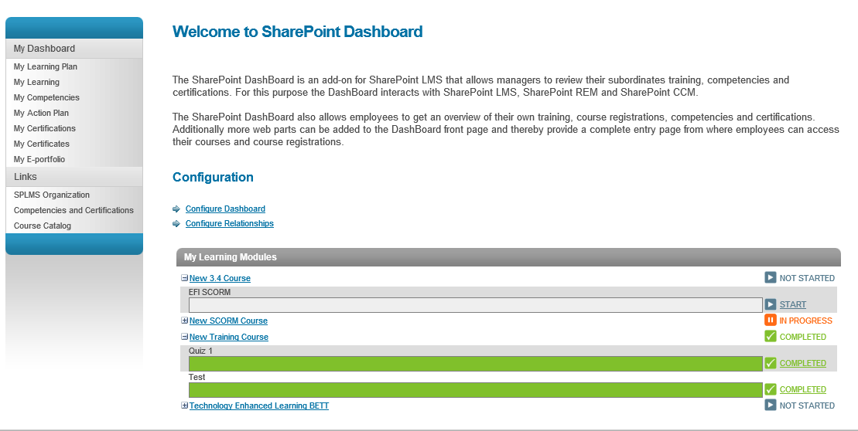
You need to activate the My Learning Modules in the Site Collection Features, once this has been activated you will see a ‘Elearningforce’ category under the web parts and you will find it there. Please be aware of the earlier version of the My Learning Module which is not inside the Elearningforce category.
Then select:
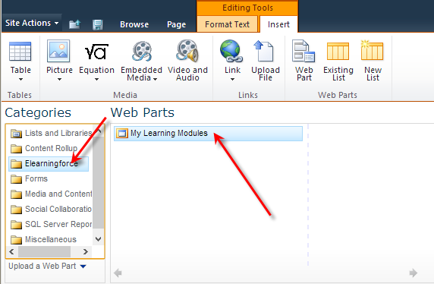
BUT DON’T SELECT THIS ONE!
